1-2 Points, Lines, and Planes

Essential Understanding:

Term | Definition | Naming | Picture
Point
Line
Plane
Collinear Points
Coplanar
Segment
Ray
Opposite Rays
Intersection of two lines
Intersection of two planes

Finding the intersection of two planes

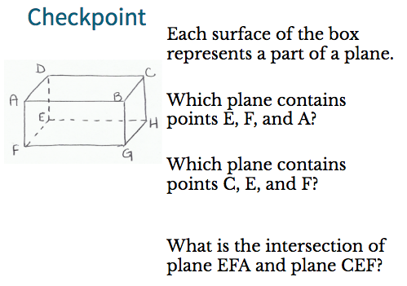

Assignment: pg 16-17 #8-30, 40-42

