1-3 Measuring Segments

Postulate: is an accepted statement or fact used as basic building blocks in geometry.

Ruler Postulate:
Every point on a line can be paired with __________________________________.

The number that corresponds to a point is called the ____________________________________.

The distance between two points is:

This value is the length of the line segment.

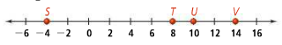
Example 1:

Length of ST | Length of UV | Length of SV

Segment Addition Postulate:

Meaning: You can add the length of 2 or more segments to get the length of a longer segment.

Example 2

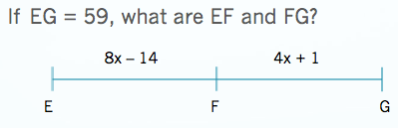

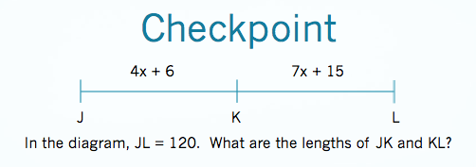

Congruent Segments:

Midpoint:

Segment Bisector:

Example 4
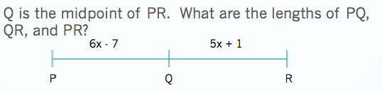

Assignment: Pg 24 #8-22 even, 26, 39-41

