Chapter 1 Practice
Evaluate the expression:
- k + 9 when k = 7 2) 3.5 + t when t = 0.9

3) $\frac{m}{5} when m=9.5$ 4) $x^{3} when x= \frac{2}{3}$

5) 25 – 7 + 8 6) $8^{2}÷4+12$

7) $\frac{3^{3}-7}{2}$ 8) 3 + 4(3 + 24)

9) Translate into an expression: three fourths of a number m.
10) Translate into an expression: the difference of a number y and 3.
11) Translate into an expression: The quotient of a number x and 7.
12) Translate into an expression: 6 more than 3 times a number n.
13) Write an expression for the situation: Number of minutes left in a 45 minute class after m minutes have gone by.
14) Write an expression for the situation: Number of meters in c centimeters
15) Write an equation or inequality: The product of 12 and the difference of a number r and 4 is 72.
16) Write an equation or inequality: The difference of a number q and 18 is greater than 10 and less than 15.
Chapter 2:
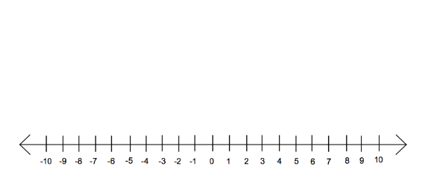
Graph the numbers on a number line and tell which is greater:
17) 0 and -4 18) -5 and -3

Tell whether each number in the list is a whole number, integer, or rational number. List in order from least to greatest.
19) 0.25, $\frac{1}{8}, -\frac{1}{10}, -2.5, -\frac{9}{5}$

Find the sum:
20)$3\frac{2}{3}+(-5\frac{3}{8})$ 21) -25 + (-36) 22) -75 + 58

Find the difference:
23) -17 – 20 24) 16 – (-50) 25) -12.8 – (-5.6)

26) Evaluate the expression when x = 1.5 and y = -4: -y – (-4)
27) Evaluate the expression when x = 1.5 and y = -4: x – (10 – y)
Find the product:
28) $\frac{2}{3}(-36)$ 29) -4.1(-3.5) 30) 1.1(-0.5)(-4)

Use the distributive property to write an equivalent expression.
31) 8 (x + 4) 32) $\frac{7}{12}(24r+12)$ 33) -3( k – 14)

Find the quotient:
34) $\frac{5}{9}÷(-5)$ 35) $-\frac{5}{6}÷-\frac{6}{5}$ 36) $\frac{-7}{8}÷-4$

Evaluate the expression
37) $-\sqrt{36}$ 38) $±\sqrt{144}$ 39) $\sqrt{6400}$

Approximate the square root to the nearest integer.
40) $\sqrt{135}$ 41) $-\sqrt{56}$

Chapter 3:
Solve the equation. Check your solution
42) x + 4 = 20 43) 7h = 63 44) $\frac{y}{-3}=8$

45) 4x + 3 = 27 46) 50 = 7y – 6 47) 12w – 5 – 3w = 40

49) 5x – 3(x – 5) = 13 50) 10 – 2x = 3x – 20 51) $\frac{3}{4}\left(2y-8\right)=6$

52) 8x – 4 = 3x + 6 53) 9 + 4y = 2(3 – y) 54) $\frac{7}{x}=\frac{14}{16}$

Write the sentence as a proportion. Then solve the proportion.
55) 5 is to 7 as 15 is to x. 56) 6 is to 18 as y is to 3.

Solve proportion and check your solution.
57) $\frac{12}{x}=\frac{6}{7}$ 58) $\frac{3b}{5b-7}=\frac{8}{11}$ 59) $\frac{4.8-2w}{8}=\frac{0.4+w}{10}$

60) What percent of 96 is 12? 61) What number is 35% of 18?

62) 14 is 40% of what number? 63) What percent of 125 is 30?

Solve the equation for x.
64) ax – b = c 65) a(b – x) = c

Write the equation so that y is a function of x.
66) 5x + y = 10 67) 7x + 3y = 6 – 5x

Chapter 4:
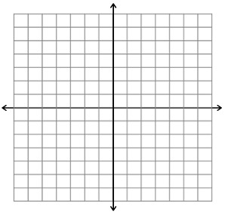
68) Plot the point in a coordinate plane. Describe the location of the point (which quadrant is it in?_
K (-4, -2) L (5, 0) M(3, -1) N(-2,2) P (0,4)

Graph the function with the given domain. Then identify the range of the function.
69) y = -2x + 2; domain: -2,-1,0,1,2 70) $y=-\frac{1}{2}x-3$; domain: -4,-2, 0, 2, 4

Graph the equations.
71) y – x = 3 72) 3x + y = 0

Use x and y intercepts to graph:
73) 2x – y = 12 74) -4x + 1.5y = 4

Find the slope of the line that passes through the points.
75) (4, 2) and (6, 8) 76) (-2, 5) and (-2, 10)
Identify the slope and y-intercept of the line with the given equation. Then graph.
77) y = 7x + 8 78) 5x + 2y = 10

Graph the direct variation equation.
80) y = 4x 81) $y-\frac{5}{4}x=0$

Find the value of x so that the function has the given value.
82) f(x) = -7x – 3; -17 83) t(x) = 3x + 1; -11

Graph the function. Compare the graph with the graph of f(x) = x
84) m(x) = x – 2 85) h(x) = -2x

