1. Which number is irrational?
- $\sqrt{9}$
- $\sqrt{8}$
- 0.333333
- $\frac{2}{3}$

2. Which point on the accompanying number line best represents the position of $\sqrt{5}$?

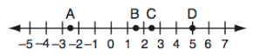

3. Between what two whole number is $\sqrt{125}$?

- 63 and 64
- 62 and 63
- 12 and 13
- 11 and 12

4. The square root of a number is between 8 and 9. Which of these could be that number?
a) 17
b) 63
c) 71
d) 89

5. Between which two integers does $\sqrt{29}$ lie?
a) 4 and 5
b) 5 and 6
c) 13 and 14
d) 14 and 15

Turn in questions #1-5 and then you may get a calculator to answer questions 6 – 14

6. Some real numbers are listed below.

$\sqrt{15} π 3 \sqrt{7}$

What is the order of the real numbers from least to greatest?
a) $3 π \sqrt{7} \sqrt{15}$
b) $\sqrt{7} \sqrt{15} 3 π$
c) $\sqrt{7} 3 \sqrt{15} π$
d) $\sqrt{7} 3 π \sqrt{15}$

7) Lang’s mathematics teacher gave her the accompanying cards and asked her to arrange the cards in order from least to greatest. In what order should Lang arrange the cards?

π | $$\sqrt{8}$$ | $$3.\overline{1}$$ | $$2\sqrt{3}$$ | $$2\frac{4}{5}$$

8) If K = $\sqrt{31}$ and M = $\sqrt{26}$ which graph most closely represents the locations of K and M on a number line?

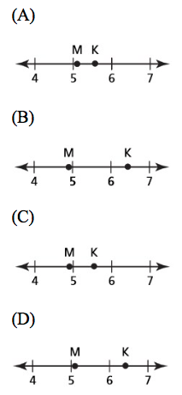

9) Jennifer cooks $2\frac{1}{3}$ cups of rice. Which statement correctly describes the number of cups of rice Jennifer cooks?
a) The number of cups of rice is a rational number because it can be written as 2.$\overline{3}$.
b) The number of cups of rice is a rational number because it can be written as 2.13.
c) The number of cups of rice is an irrational number because it can be written as 2.$\overline{3}$.
d) The number of cups of rice is an irrational number because it can be written as 2.13.

10) Which inequality correctly compares one rational number and one irrational number?
a) $\sqrt{17}>\frac{239}{58}$
b) $\frac{4π}{3}>\sqrt{17}$
c) $4.\overline{19}$ > $\frac{239}{58}$
d) $\frac{4π}{3}>\frac{239}{58}$

11) Which number is irrational?
a) $\frac{5}{4}$
b) $0.\overline{3}$
c) $\sqrt{121}$
d) π

Distance from Craig’s Home
Location in town | Distance (miles)
Library | $$3\sqrt{6}$$
Mall | $$4\sqrt{5}$$
School | $$5\sqrt{3}$$
Park | $$6\sqrt{2}$$
12) The table below shows the distance, in miles, from Craig’s home to different locations in his town.

Which statement comparing the distances, in miles, of two of the locations from Craig’s home is correct?
- The park is closer to Craig’s home than the library.
- The school is closer to Craig’s home than the park.
- The library is farther from Craig’s home than the mall.
- The mall is farther from Craig’s home than the school.

13) Four points representing $π, \sqrt{10}, 3.1\overline{6}, \frac{25}{8}$ are plotted on the number line shown below.
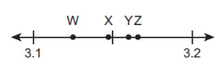
Which statement correctly identifies the location of one of the points and whether it is a rational or an irrational number?

- Point W is the location of $\frac{25}{8}$, and it is an irrational number.
- Point X is the location of π and it is an irrational number.
- Point Y is the location of 3.16, and it is a rational number.
- Point Z is the location of $\sqrt{10}$, and it is a rational number.

14) Kelsey plots $\sqrt{56}$ on a number line without the use of a calculator.

Explain how Kelsey could find between which two consecutive whole numbers she should plot $\sqrt{56}$.

Also explain how she can determine to which of these two whole numbers$\sqrt{56}$ is closest.

EC: The value of $\sqrt{x^{2}-9}$ is a real and irrational number when x is equal to

- 5
- 0
- -3
- 4

